VIZ1 – Session 7: Visualization Workshop
Dataset: boys.csv (boyband dataset)

1. DATA EXPLORATION

Use the boyband dataset. Explore the data, and find:

The dataset type: Multidimensional table

The data types:

(If applicable) The attribute types, including keys and values:

Attribute name | Attribute type | Key/Value | Ordering direction
band | Categorical | Key with name
name | Categorical | Key with band
dob | Quantitative | Value | Sequential
hair_color | Categorical | Value
hair_frosted | Categorical | Value
hair_length | Ordinal | Value | Sequential
hair_style | Categorical | Value
eyes | Categorical | Value
facial_hair | Categorical | Value
accessories | Categorical | Value
top_style | Categorical | Value
bottom_style | Categorical | Value
height | Quantitative | Value | Sequential
skin | Ordinal | Value | Sequential
instrument | Categorical | Value
shirt_color | Categorical | Value
jacket_color | Categorical | Value
bottom_color | Categorical | Value

2. GENERATE QUESTIONS

Generate as many exploratory questions as you can – at least 5.
Good keywords to lead to questions: Comparison, Distribution, Composition, Trend, Relationship, Ranking, Change, Outliers, Clusters

1. How do changes in hair_style pair with facial_hair
2. Is there a correlation between hair_frosted and dob?
3. What is the relationship between accessiories and dob?
4. Is there a trend regarding skin and bottom_style?
5. How many members are there in a boy band?
6. Do bands cluster into overall looks, such as suits versus streetwear?
7. Is there a trend in names containing alias with dob in comparison to hairstyle.
8. What is the correlation between a members birth month and their chance of joining a boyband? (Cyclical)
9. Is there a relation between band size and color contrast? (Color attributes need to be made ordinal so there is a color scale to define contrast)
10. Is there a relation between band size and how uniform the band members colors are?

3. DEFINE YOUR VISUALIZATION QUESTION

Select one question:

Do larger boybands coordinate their colours more or less than smaller bands, measured as how close each band is to all members wearing the same colour (0 = all different, 1 = all matching)?
- My visualization investigates whether band size is related to how uniformly the members dress.
- It contains the variables band, members per band, bottom colour, and a derived uniformity score (0–1).
- The reader should first notice whether larger bands sit higher or lower on uniformity.
- The reader should be able to explore each band's members and the actual colours they wore.

4. CREATE VISUALIZATION IDEAS (1)

Sketch three different visualization ideas. Each sketch should include:
• Overall layout
• Title
• Marks
• Channels
• Radial geometry
• Interaction

Sketch A: What is the relationship between the band uniformity and signature colors?
• Title:
• Overall layout:
• Marks:
• Channels:
• Radial geometry:
• Interaction:
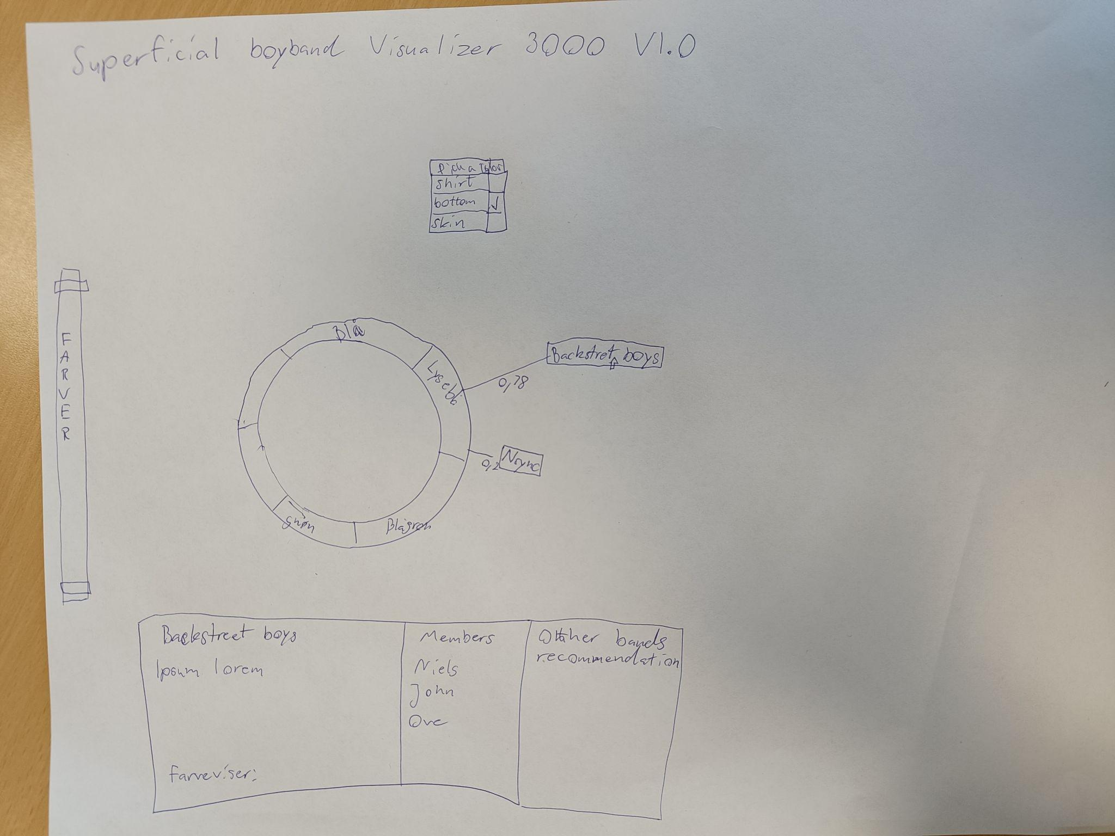

Sketch B: Do larger boybands coordinate their colours more or less than smaller bands
• Title:
• Overall layout:
• Marks:
• Channels:
• Radial geometry:
• Interaction:
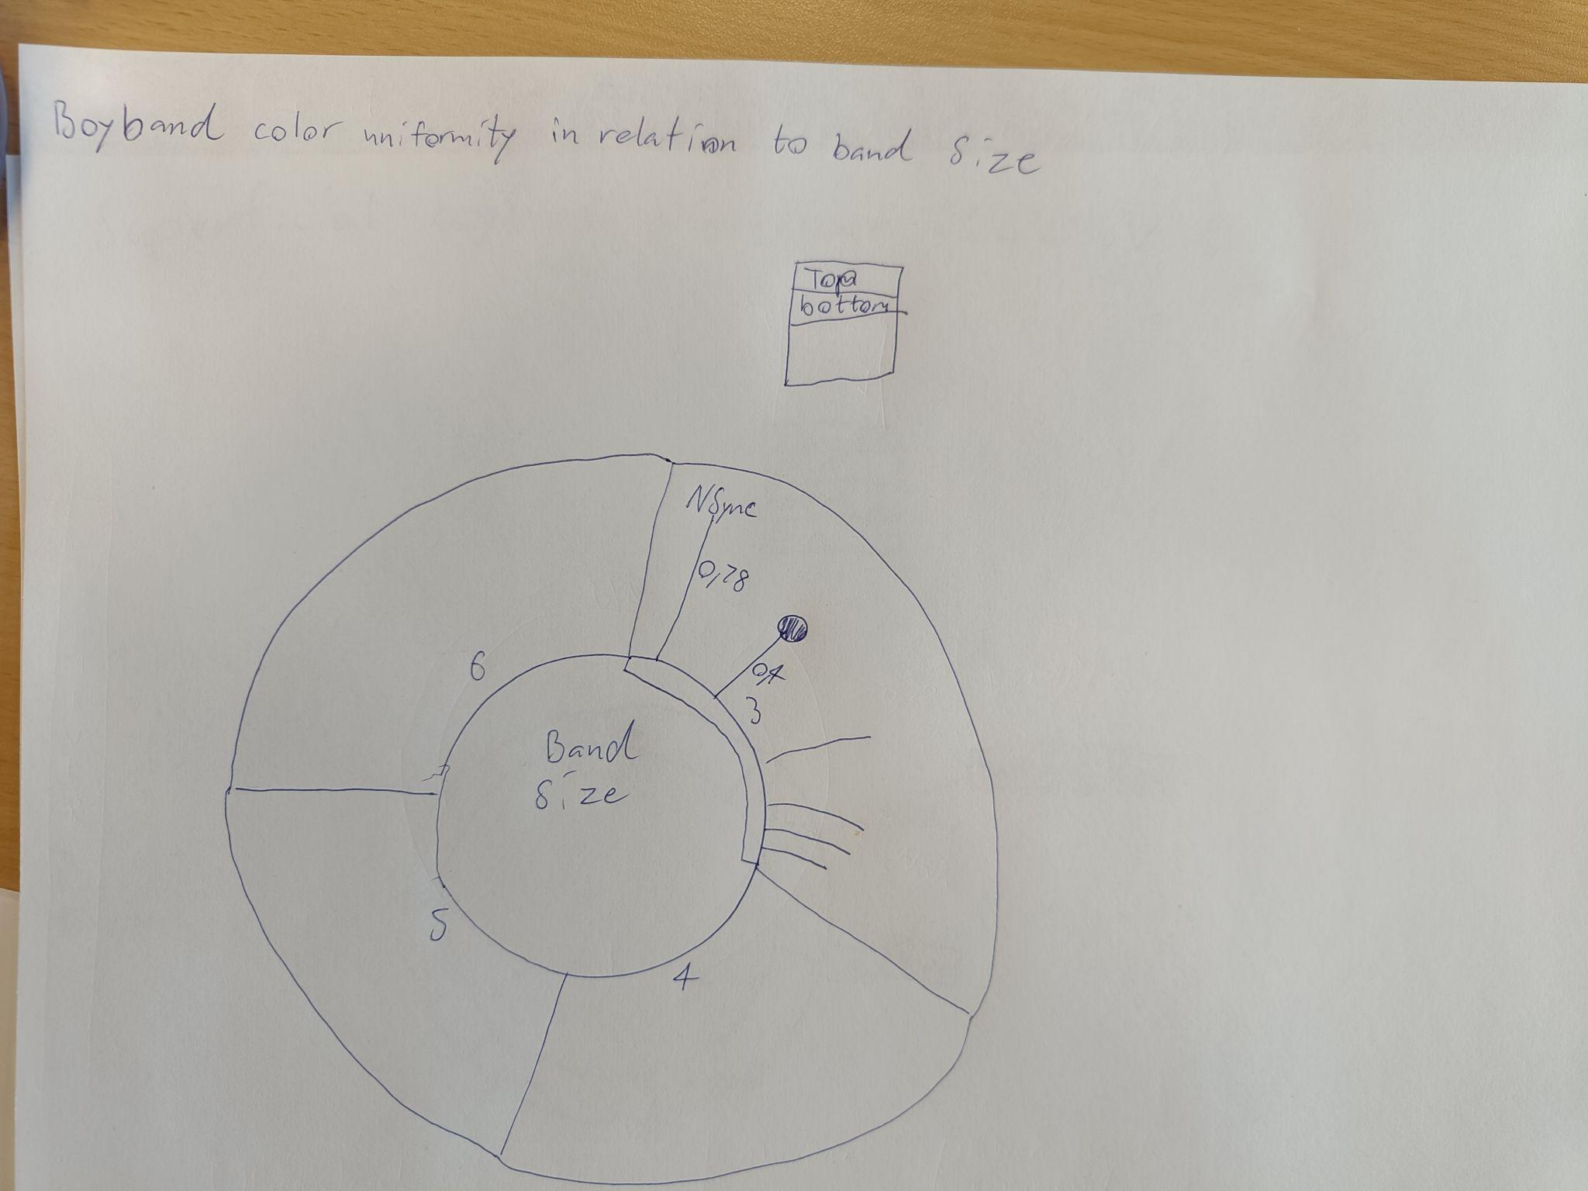

Sketch C: What colors are most common grouped on zodiac signs (See wireframe in repo)
• Title:
• Overall layout:
• Marks:
• Channels:
• Radial geometry:
• Interaction:

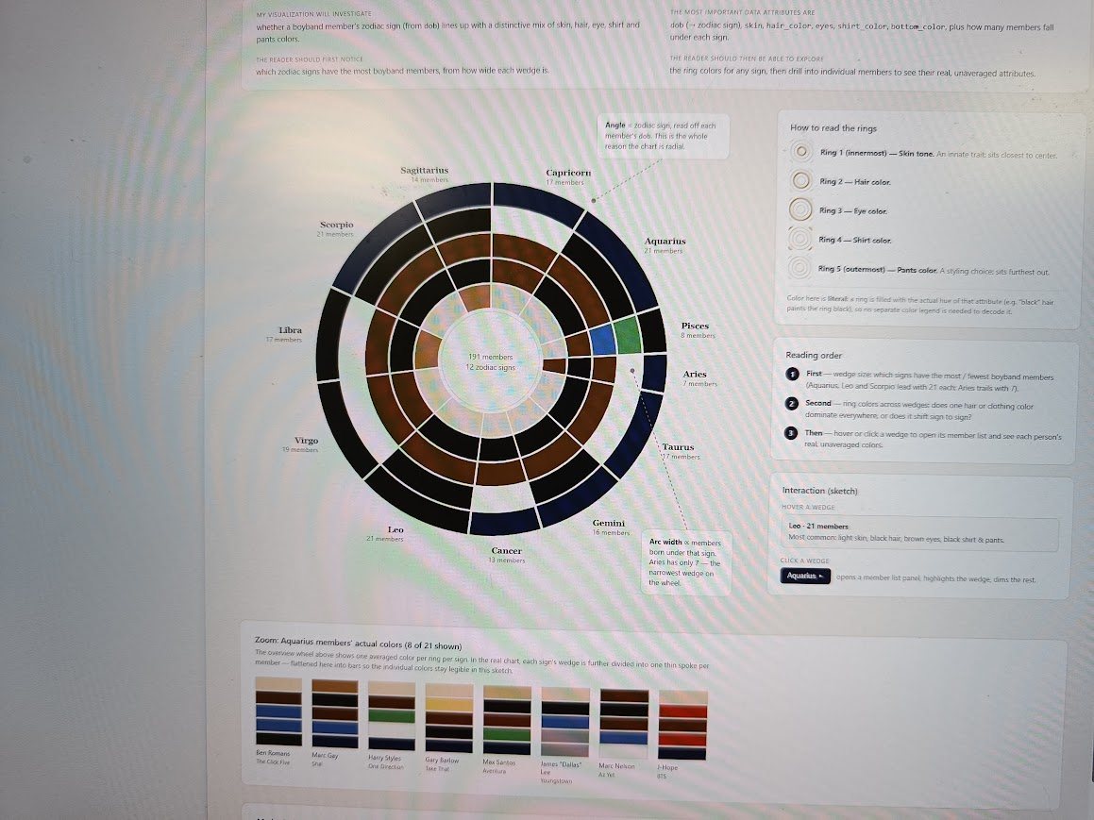

5. CREATE VISUALIZATION IDEAS (2): MARKS AND CHANNELS

For each sketch, answer the following:

Sketch A
• What are the marks?
• What are the channels?
• What do they communicate?

Sketch B
• What are the marks?
• What are the channels?
• What do they communicate?

Sketch C
• What are the marks?
• What are the channels?
• What do they communicate?

Then compare the three alternatives:

6. CREATE VISUALIZATION IDEAS (3): RADIAL GEOMETRY

Include radial geometry in your sketches.

Why are angles appropriate?

Include your marks and channels:

7. CREATE VISUALIZATION IDEAS (4): INTERACTION

Choose one or more interactions:

Why do you want to include them in your visualization?

Sketch the expected interaction in a wireframe.

8. PEER FEEDBACK (11:20)

Pitch your idea to another group.

Review:
• Is the visualization question clear?
• Are the marks meaningful?
• Are the channels effective?
• How does the arc layout communicate?
• Is the interaction helpful?
• What else should be improved?

